

Insurance Premium Prediction

High-Level Design (HLD)

Internship Project



Rahul Sharma

**Contents**

Contents ………………………………………………………………………2 Abstract…………………………………………………………………… ….3

1. Introduction……………………………………………………………….. 4

1.1 Why this High-Level Design Document?........................................... …...4

1.2 Scope……………………………………………………………… ……..4

2. General Description……………………………………………… ………...5

2.1 Product Perspective & Problem Statement………………………… …….5

2.2 Tools Used………………………………………………………… …......5

3. Design Detail…………………………………………………………… ….6

3.1 Functional Architecture……………………………………………… …..6

3.2 Optimization………………………………………………………… .......6

4. Deployment…………………………………………………………………7

**ABSTRACT**

Accidents and disasters can and do happen. If you aren’t flush with cash to handle them, you could face huge financial struggles and setbacks. Insurance is one way to protect your life, your health, your ability to earn an income and to keep a roof over your head when things go wrong.

Many people in their 20s may feel they are healthy enough to skip out on health insurance. When you rarely see a doctor, and especially if things are tight financially, it may seem like a good idea to cut the health insurance expense completely from your budget.

* Health insurance is essential for maintaining medical health, but also for keeping potential medical expenses manageable.
* The fallout from a medical emergency or unforeseen expense could extend beyond your immediate finances to loss of income and possible bankruptcy.
* Though the Affordable Care Act (ACA) made health insurance mandatory, you are not penalized if you don't have coverage.
* There is a wide range of health insurance plans available, so you should assess your situation to find the best fit for you.

**1. INTRODUCTION**

**1.1Why this High-Level Design Document?**

The purpose of this High-Level Design (HLD) document is to add the necessary detail to the current project description to represent a suitable model for coding. This document is also intended to help detect contradictions before coding and can be used as a reference manual for how the modules interact at a high level.

The HLD will:

• Present all the design aspects and define them in detail

• Describe the user interface being implemented

• Describe the hardware and software interfaces

• Describe the performance requirements

• Include design features and the architecture of the project

• List and describe the non-functional attributes, like:

● Security

● Reliability

● Maintainability

● Portability

● Reusability

● Application compatibility

● Resource utilization

● Serviceability

**1.2 Scope**

The HLD documentation presents the structure of the system, such as the database architecture, application architecture (layers), application flow (Navigation), and technology, Architecture. The HLD uses non-technical to mildly-technical terms, which should be understandable to the administrators of the system.

**2. General Description**

**2.1 Product Perspective & Problem Statement**

The goal of this project is to give people an estimate of how much they need to be based on their health situations. After that, customers can work with any health insurance carrier and its plans and perks while keeping the projected cost from our study in mind. This can assist a person in concentrating on the health side of an insurance policy rather than the ineffective part.

**2.2 Tools used**

NumPy, Pandas, Seaborn, Matplotlib, MS-Excel, Jupyter Notebook, and Python Programming Language are used to build the whole framework.



 



**3. Design Details**

The dataset contains 4 numerical features (age, BMI, children, and expenses) and 3 nominal features (sex, smoker, and region) that were converted into factors with numerical values designated for each level.

The purpose of this exercise is to look into different features to observe their relationship and plot a multiple linear regression based on several features of individuals such as age, physical/family condition, and location against their existing medical expenses to be used for predicting future medical expenses of individuals that help medical insurance to decide on charging the premium.

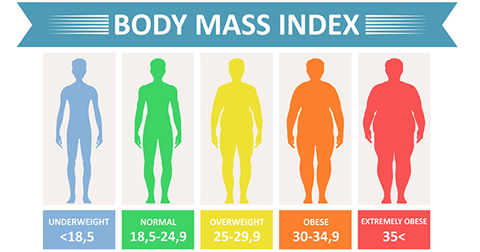

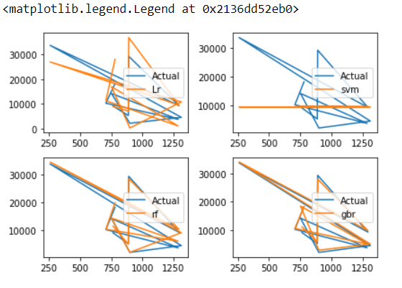

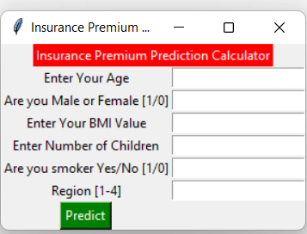

**4. Deployment**

Prioritizing data and analytics couldn’t come at a better time. Your company, no matter what size, is already collecting data and most likely analyzing just a portion of it to solve business problems, gain competitive advantages, and drive enterprise transformation. With the explosive growth of enterprise data, database technologies, and the high demand for analytical skills, today’s most effective IT organizations have shifted their focus to enabling self-service by deploying and operating Power BI at scale, as well as organizing, orchestrating, and unifying disparate sources of data for business users and experts alike to author and consume content.